**ARRAYS, FUNCTIONS**

**AND POINTERS**

**LAB # 10**



**Spring 2019**

**CSE102L Computer Programming Lab**

Submitted by: **SHAH RAZA**

Registration No. : **18PWCSE1658**

Class Section: **B**

“On my honor, as student of University of Engineering and Technology, I have neither given nor received unauthorized assistance on this academic work.”

Student Signature: ______________

Submitted to:

**Engr. Madiha Sher**

May 13,2019

Department of Computer Systems Engineering

University of Engineering and Technology, Peshawar

## Objectives:

To learn to write programs to model repetitive data using arrays

To learn use of Arrays with functions

To learn the pointer arithmetic

**TASK #1:**

Write a program in C++ to delete an element at desired position from an array.

**Code:**

#include <iostream>

using namespace std;

void input(int A[],int SIZE) //input Function Definition

{

for (int i=0;i<SIZE;i++)

{

cin>>*(A+i);

}

}

void Delete(int A[],int SIZE,int pos) //Delete Function Definition

{

int i=pos-1;

for(int c=0;c<SIZE-pos;c++,i++)

{

*(A+i)=*(A+i+1);

}

*(A+i)=0;

}

void Output(int A[],int SIZE) //Output Function Definition

{

for(int i=0;i<SIZE;i++)

cout<<*(A+i);

}

int main()

{

int SIZE; //Variable declaration

cout<<"Please enter the size of Array: "; //Display message

cin>>SIZE; //Input SIZE

int A[SIZE],pos;

cout<<"Input Array: \n"; //Display message

input(A,SIZE); //input Function Call

cout<<"Input the position where to delete: ";//Display message

cin>>pos; //Input pos

Delete(A,SIZE,pos); //Delete Function Call

cout<<"After Deleting: "; //Display message

Output(A,SIZE); //Output Function Call

return 0;

}

**Output (Compilation, testing and debugging):**

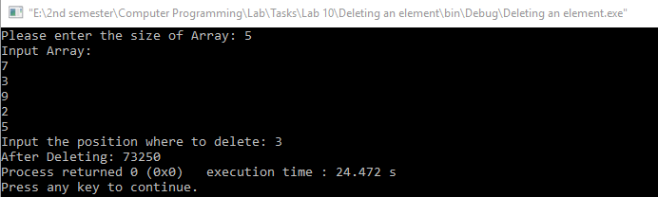

**TASK #2:**

Write a program to find the second largest element in an array.

**Code:**

#include <iostream>

using namespace std;

void bubblesort(int A[],int SIZE) //bubblesort Function Definition

{

for (int i=0;i<SIZE;i++)

{

for (int j=0;j<SIZE-1;j++)

{

if(*(A+j)<*(A+j+1))

{

int temp=*(A+j);

*(A+j)=*(A+j+1);

*(A+j+1)=temp;

}

}

}

}

void input(int A[],int SIZE) //input Function Definition

{

for (int i=0;i<SIZE;i++)

{

cin>>*(A+i);

}

}

int main()

{

int SIZE; //Variable declaration

cout<<"Enter the size of Array: "; //Display message

cin>>SIZE; //Input SIZE

int A[SIZE]; //Array Declaration

cout<<"Enter Array: \n"; //Display message

input(A,SIZE); //input Function Call

bubblesort(A,SIZE); //bubblesort Function Call

cout<<"The second largest number is: "<<*(A+1); //Display second largest number in Array

return 0;

}

**Output (Compilation, testing and debugging):**

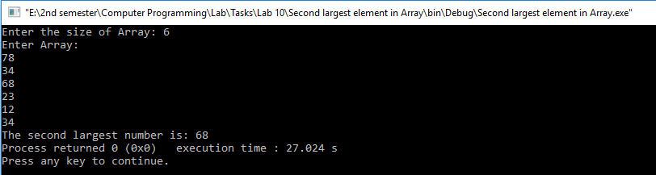

**TASK #3:**

Write a program to find the number of times (frequency) a given number occurs in an array.

**Code:**

#include <iostream>

using namespace std;

void input(int A[],int SIZE) //input Function Definition

{

for (int i=0;i<SIZE;i++)

{

cin>>*(A+i);

}

}

int frequency(int A[],int SIZE,int num) //frequency Function Definition

{

int counter=0;

for(int i=0;i<SIZE;i++)

{

if(*(A+i)==num)

counter++;

}

return counter;

}

int main()

{

int SIZE; //Variable declaration

cout<<"Enter the size of Array: "; //Display message

cin>>SIZE; //Input SIZE

int A[SIZE],num;

cout<<"Input an Array: \n"; //Display message

input(A,SIZE); //input Function Call

cout<<"Key number: "; //Display message

cin>>num; //Input num

int counter=frequency(A,SIZE,num); //frequency Function Call

cout<<"Frequency of "<<num<<" in this Array is: "<<counter;

return 0;

}

**Output (Compilation, testing and debugging):**

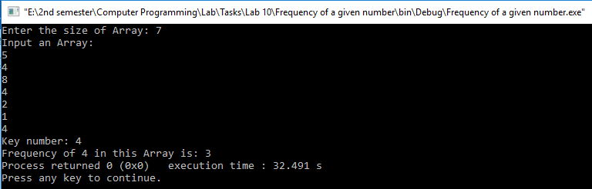

**TASK #4:**

Write a program to check whether an array is subset of another array.

The given first array is: 4 8 7 11 6 9 5 0 2

The given second array is: 5 4 2 0 6

The second array is the subset of first array.

**Code:**

#include <iostream>

using namespace std;

const int SIZE=6,size2=3;

void input(int A[SIZE]) //input Function Definition

{

for (int i=0;i<SIZE;i++)

{

cin>>*(A+i);

}

}

void inputb(int A[size2]) //inputb Function Definition

{

for (int i=0;i<size2;i++)

{

cin>>*(A+i);

}

}

void subset(int A[SIZE],int B[size2]) //subset Function Definition

{

int counter=0;

for(int i=0;i<SIZE;i++)

{

for(int j=0;j<size2;j++)

{

if(*(B+j)==*(A+i))

counter++;

}

}

if(counter==size2)

cout<<"This is a subset of main Array";

else

cout<<"This is not a Subset of main Array";

}

int main()

{

int A[SIZE],B[size2]; //Array Declaration

cout<<"Input main Array: \n"; //Display message

input(A); //input Function Call

cout<<"Input subset: \n"; //Display message

inputb(B); //inputb Function Call

subset(A,B); //subset Function Call

return 0;

}

**Output (Compilation, testing and debugging):**

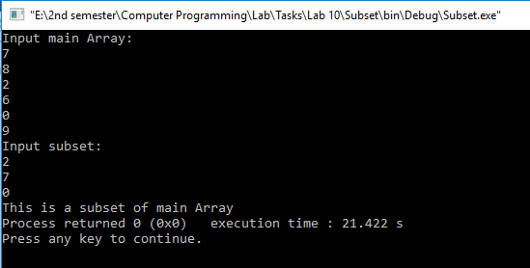

**TASK #5:**

Write a program to move the given number to the end of a given array.

**Code:**

#include <iostream>

using namespace std;

void input(int A[],int SIZE) //input Function Definition

{

for (int i=0;i<SIZE;i++)

{

cin>>*(A+i);

}

}

void TakeToEnd(int A[],int SIZE,int num) //TakeToEnd Function Definition

{

for(int i=0;i<SIZE;i++)

{

for(int j=0;j<SIZE-1;j++)

{

if(*(A+j)==num)

{

int temp=*(A+j);

*(A+j)=*(A+j+1);

*(A+j+1)=temp;

}

}

}

}

void Output(int A[],int SIZE) //Output Function Definition

{

for(int i=0;i<SIZE;i++)

cout<<*(A+i);

}

int main()

{

int SIZE; //Variable declaration

cout<<"Enter the size of Array: "; //Display message

cin>>SIZE; //Input SIZE

int A[SIZE],num;

cout<<"Input an Array: \n"; //Display message

input(A,SIZE); //input Function Call

cout<<"Enter a number: "; //Display message

cin>>num; //Input num

TakeToEnd(A,SIZE,num); //TakeToEnd Function Call

cout<<"After taking "<<num<<" to the end: "; //Display message

Output(A,SIZE); //Output Function Call

return 0;

}

**Output (Compilation, testing and debugging):**

